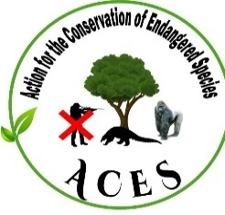
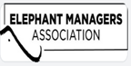

Final Project Report

Prepared by
ANGWA GWENDOLINE
Project Coordinator ACES

Contents
Executive Summary 3
1. Introduction 4
2. Teaching Methods and Approaches 4
3. Curriculum Breakdown 4
4. Pre-Test and Post-Test Evaluation 5
5 Results and Analysis 5
5.1 Outdoor Games 5
5.2. Change in knowledge before and after intervention 6
5.3. Change in Attitude before and after intervention 6
5.4. Change in Behavior before and after intervention 6
6. Student Feedback 7
8. Shortcomings and Adjustment. 7
9. Conclusion 7
APPENDICES 9
Appendix A: Pre-Test and Post-Test Questionnaire 9
Appendix B: Pre-Test and Post-Test Results 10
Analysis on knowledge 10
Analysis on Attitude 11
Analysis on Behavior 12
Appendix C. Teaching and training sessions with students 13
Appendix D. Outdoor games 27
Appendix E. Brochure for students and banner 28
Appendix F. Testimonials 29

Acknowledgement
We acknowledge the ELEPHANT MANAGERS ASSOCIATION for their financial support to this project. We also thank the school administration for allowing us teach conservation and engage students in our EE program. We appreciate M&C football academy for their collaboration in the successful football games. The school delegate for their cooperation without leaving out Dr ANYA Praise for making out time to teach our students and sharing wildlife documentaries on elephant to enhanced the program. We cannot also forget to thank Mr Ngange Boris ( the community Based wildlife Monitor for Mount Cameroon for also sharing an inside on the threat to elephant in the area and giving a talk to students on the need to better protect the treasures of our forest. To all ACES Staff, volunteers and well-wishers we say thank you for your support.

Executive Summary
The Elephant Conservation Education Program, implemented by Action for Conservation and Environmental Sustainability (ACES) Cameroon and funded by the Elephant Managers Association (EMA), was conducted over a six (6) months period. The project involved three government secondary schools (Government High School (GHS) Muea, Government Bilingual High School (GBHS) Molyko adjacent the Mount Cameroon National Park (MCNP), and Government Bilingual High school (GBHS) Belabo). The focus was to raise awareness on Elephant conservation and built stewards of Biodiversity by addressing critical gaps in student awareness of elephant ecology, threats, and conservation strategies. The program employed interactive lectures, role-playing debates, audiovisual resources, outdoor conservation games and creative activities to engage students, alongside pre-and post-test assessments measuring Knowledge, Attitude, and Behavior (KAB) shifts. Results revealed significant improvements: knowledge of elephant classification rose by 46%, understanding of their ecological roles increased by 40%, and recognition of multifaceted threats (poaching, habitat loss, human-elephant conflict) surged by 18%. Attitudinal shifts included a 50% rise in students self-identifying as "very interested" in conservation and a 48% increase in those acknowledging personal responsibility for protecting elephants. Behaviorally, participation in conservation activities grew by 26%, with 70% of students committing to advocacy post-program. Testimonials highlighted heightened ecological awareness, community leadership, and youth empowerment, while challenges were mitigated through adaptive strategies. Recommendations for future initiatives include integrating forest field visit. The program successfully bridged knowledge gaps fostered pro-conservation mindsets, and laid the groundwork for scalable community-driven solutions, underscoring the value of experiential environmental education in nurturing stewardship among Cameroon’s youth.

1. Introduction
The Elephant Conservation Education Program was a Six month-long initiative carried out in three government secondary schools (Government High School (GHS) Muea, Government Bilingual High School (GBHS) Molyko and Government Bilingual High school (GBHS) Belabo) in the Southwest and East Region of Cameroon. This program was funded by the Elephant Managers Association (EMA) to educate secondary school students about elephants, their ecological roles, threats they face, and human-elephant conflict. The ultimate goal was to foster conservation awareness, behavioral change, and community impact by equipping students with the knowledge and motivation to become conservation advocates. To measure the program’s effectiveness, a pre-test and post-test questionnaire was administered to assess changes in students' Knowledge, Attitude, and Behavior (KAB). Additionally, student testimonials and behavioral tracking were integrated into the impact assessment to provide a well-rounded evaluation. An outdoor learning was organized with student at the Integrated Centre for Environmental Education (ICEC) where the students engage in environmental games. EVERYTHING IS CONNECTED TO EVERYTHING. It is a fun filled game and the student play end relax while learning. Furthermore, a sport competition was organized and we printed Jerseys for two team: ELEPHANT FC, and GORILLA Strikers. The match was very entertaining and ended in draws. The match was a way of ending our program and wishing the students happy holidays.

2. Teaching Methods and Approaches
The program employed a variety of interactive and participatory teaching methods to maximize student engagement, including interactive lectures and discussions featuring open Q&A sessions, brainstorming activities, and student-led dialogues. Audio-visual presentations, such as YouTube documentaries from National Geographic, WWF, and IUCN, were utilized to help students visualize concepts through videos and images of elephants in their natural habitat. Role-playing and debates allowed students to assume roles like farmers, conservationists, and government officials to explore solutions to human-elephant conflict, while creative expression activities, such as poster-making and essay-writing competitions, provided opportunities for students to articulate their understanding of conservation. To assess the program's impact, pre-test and post-test questionnaires were administered to measure changes in knowledge, attitudes, and behaviors. Additionally, community engagement tasks encouraged students to share their learning with family members and bring reports on the output of the discussions, further reinforcing the program's educational objectives.

3. Curriculum Breakdown
The curriculum was structured into a four-week program, each week addressing a core theme in elephant ecology, threats, and conservation. Month 1 introduced students to elephant biology and behavior, covering the three extant species, that is, African Savannah (Loxodonta africana), African Forest (Loxodonta cyclotis), and Asian Elephants (Elephas maximus) with emphasis on their physical adaptations, complex social hierarchies, and cognitive abilities. Students engaged in research activity, presenting unique facts about elephant communication or tool-use behaviors. Month 2 focused on elephants as ecosystem engineers, detailing their ecological roles in seed dispersal, forest regeneration through vegetation modification, and landscape engineering via water-hole creation. Month 3 examined anthropogenic threats, including poaching trends, habitat fragmentation from agriculture, climate change effects on food availability, and human-elephant conflict drivers. Month 4 focused on conflict mitigation and sustainable solutions, exploring causes of human-elephant competition (e.g., crop raiding, land encroachment) and evidence-based strategies such as beehive fences, chilly-based deterrents, and habitat corridors. A role-playing simulation tasked students with negotiating stakeholder perspectives; farmers, conservation NGOs, and policymakers—to debate balanced solutions for coexistence. Month 5 focused on outdoor visit to the Integrated Conservation Education Centre (ICEC) in Limbe for outdoor learning and environmental games. Month 6 focused on sport competition between Elephant FC and the Gorilla Strikers to further gauge public interest in elephant conservation. Each Month integrated foundational knowledge with applied activities to increase the interest of conservation amongst youth and hence ensuring the long-term protection of Elephant and other endangered wildlife species.

4. Pre-Test and Post-Test Evaluation
We employed a structured Knowledge, Attitude, and Behavior (KAB) questionnaire, administered pre- and post-intervention, to quantitatively evaluate shifts in student awareness, perceptions, and engagement concerning elephant conservation. The knowledge component assessed foundational understanding through questions on elephant species identification, ecological roles (e.g., seed dispersal, habitat engineering), and recognition of anthropogenic threats such as poaching and habitat fragmentation. The attitude segment gauged students’ perceptions of elephants’ environmental significance and their commitment to supporting conservation initiatives. The behaviour module analyzed self-reported actions, including pre-existing conservation discussions with peers, post-program advocacy efforts, and intentional avoidance of ivory products. This KAB framework provided a holistic lens to measure the program’s efficacy in fostering not only cognitive gains but also attitudinal alignment and actionable behavioural changes toward conservation stewardship.

5 Results and Analysis

5.1 Outdoor Games
We organized two outdoor programs for the two new clubs created in GBHS Muea and GBHS Molyko. The two schools were involved in different outdoor programs. GBHS Molyko environmental club visited the Integrated Conservation Education Centre and they were expose to several learning tools and storytelling books. Our interest was to let them understand the concept of “everything is connected to everything”. It was an interesting game and they relax while learn. The idea was to groom lovers of the environment and potential stewards for biodiversity conservation. 67% of them express their interest in furthering the university education on Natural resource management while the others indicated to always advocate for species conservation and environmental protection where ever they might be. We also organized a sport competition between ELEPHANT FC VS GORILLA STRICKERS. The sport game was so interesting and the students were excited. The sport game organized with student from GBHS Muea was coordinated by the M &C football academy and it was played in the Likoko Membea school field. It ended in a one-all draw. And after the match we had a conservation talk with the academy and the students and we look forward to having a more and better football tournament for wildlife protection organized in the near future

5.2. Change in knowledge before and after intervention
The pre-test results showed that only 30% of participants correctly identified elephants as mammals, while 60% responded with “I don’t know,” indicating a severe knowledge gap. However, after the intervention, knowledge improved significantly, with 76% correctly identifying elephants as mammals and only 14% still unsure. This indicates a 46% increase in knowledge, demonstrating the effectiveness of the educational program. Regarding elephants' ecological role, in the pre-test, 40% believed that elephants help disperse seeds and maintain forests, while 60% either selected incorrect answers or admitted they didn’t know. After the intervention, 80% correctly identified elephants’ role, showing a 40% improvement in understanding. When asked about threats to elephants, only 20% of participants in the pre-test correctly identified "All of the above" (poaching, habitat loss, and human-wildlife conflicts) as the primary threats, while 40% thought poaching alone was the biggest threat. By the post-test, 38% correctly identified multiple threats, showing an 18% improvement in awareness. This suggests that before the intervention, students tended to focus on a single issue (poaching), but after learning more, they recognized the complexity of the threats elephants face. On conservation organizations, a staggering 80% of participants in the pre-test did not know of any organization working on elephant conservation, and only 20% could name one (mostly WWF). Post-test results showed significant progress, with 44% correctly identifying BirdLife International and other relevant conservation bodies, representing a 24% improvement in awareness of conservation efforts. This change is crucial because recognizing conservation organizations helps individuals understand who to support and engage with for conservation activities.

5.3. Change in Attitude before and after intervention
Within the pretest, Interest in elephant conservation was initially low, with only 10% of participants rating their interest as "5" (very interested) and 40% rating it as "1" (not interested at all). However, post-test results revealed a dramatic shift, with 50% now rating their interest at the highest level and 0% selecting “not interested,” indicating a 50% increase in deep engagement with the topic. Agreement with the statement that "Elephants are essential to maintaining environmental health" also improved. In the pre-test, 44% of participants disagreed with this statement, and only 8% strongly agreed. After the intervention, the number of people who strongly agreed increased to 34%, while disagreement dropped to 22%. This shows a 22% positive shift toward recognizing elephants' importance to ecosystems.
Similarly, when asked if they were concerned about threats to elephants in their community, only 2% strongly agreed in the pre-test, and 60% remained neutral. After the intervention, strong agreement increased to 38%, while neutral responses dropped to 20%, reflecting a 36% rise in active concern for elephant conservation issues. Belief in personal responsibility also improved. Initially, 40% disagreed that they had a role to play in elephant conservation, and only 2% agreed. Post-test results showed that 50% now strongly agreed with this statement, demonstrating a 48% increase in individuals who feel personally accountable for conservation efforts. This suggests that the intervention helped students see themselves as change agents rather than passive observers.

5.4. Change in Behavior before and after intervention
Before the intervention, engagement in conservation activities was low, with 40% never participating and only 15% engaging often, but after the intervention, frequent participation increased to 44%. Willingness to engage in elephant conservation also improved significantly, as the percentage of those strongly agreeing to participate rose from 16% to 38%. Support for conservation campaigns saw a similar shift, with strong agreement increasing from 2% to 34% while disagreement dropped from 28% to 2%. Interest in joining conservation clubs rose dramatically from 54% to 96%. Additionally, attitudes toward elephant conservation changed notably, initially, only 10% were highly interested, but post-intervention, 50% expressed strong interest, with no participants rating themselves as "not interested." Agreement that elephants are essential for environmental health rose from 8% to 34%, while disagreement decreased by 22%. Concern for elephant threats grew, with strong agreement jumping from 2% to 38%, a 36% increase. Personal responsibility for conservation also improved, with strong agreement rising from 2% to 50%, reflecting a 48% growth in individuals seeing themselves as active conservationists. These shifts indicate a substantial positive change in conservation awareness and engagement due to the intervention.

6. Student Feedback
At the end of the program, students were encouraged to document their key takeaways and reflections on the lessons learned. This exercise aimed to reinforce their understanding of elephant conservation while fostering a deeper appreciation for wildlife protection. The program generated significant enthusiasm among students, with many expressing a newfound appreciation for Elephants and conservation efforts: it is worthy of note that most of the feedback could not be captured on video because of security restrictions from the schools. Below are three feedbacks from the three different schools (Appendix E).

8. Shortcomings and Adjustment.
The radio and TV program arrangement we had with the local radio in Belabo did not work as plan due to constant light blackout and so the program did not take into account the radio program as indicated in the project. To make up for this, we collaborated with a football academy to promote our advocacy for conservation through football games since it is an activity that attracts a lot of people. We printed two set of Jersy’s for the two team and this also limited the participation to just a single game and we are hoping to organize the game better in future with available funding and capitalized on using this medium to promote conservation of elephant
The project was initially planned to take place in schools around Deng Deng National Park. But this time we extended to the Mount Cameroon National Park area due to the increasing HEC in the area resulting to Elephant poisoning in farmlands. We seized the opportunity to engage the people in the area including students on deep conservation issues. We explore the use of elephant researchers of Mount Cameroon and other wildlife personnel’s from the park services to raise public awareness on the need to live in harmony with Elephants.
Since the project cut across the two landscape, the resources were limited to fully engage all the EE clubs in the outdoor conservation games.

9. Conclusion
The Elephant Conservation Education Program funded by the Elephant Managers Association (EMA), successfully enhanced students’ knowledge, attitudes, and conservation behaviors. The integration of interactive learning and community outreach resulted in a positive shift in student perceptions and engagement with conservation efforts. The results show that the intervention had a profound impact on participants' knowledge, attitudes, and behaviours. Knowledge saw the most substantial improvement, with some an increased in awareness. Attitudes also shifted positively, as more students recognizing their responsibility in conservation. The increase in conservation participation and willingness to engage indicates that people are moving beyond awareness into action. Continued engagement, hands-on conservation activities, and further education will be key to sustaining and expanding these positive changes.

APPENDICES

Appendix A: Pre-Test and Post-Test Questionnaire
Elephant Conservation Questionnaire
A. Knowledge
1. Elephants are classified as:
A) Reptiles B) Mammals C) Birds D) I don’t know
2. Elephants play an essential role in the ecosystem by:
A) Dispersing seeds and maintaining forests B) Pollinating flowers C) Controlling pest populations D) I don’t know
3. What is the primary threat to elephant populations in Cameroon?
A) Poaching B) Habitat loss C) Human-wildlife conflicts D) All of the above
4. Which organization or group is known for elephant conservation efforts in Cameroon?
A) World Wide Fund for Nature (WWF) B) International Elephant Foundation C) Bio Conservation Club
D) I don’t know D. Others (Specify)
________________________________________ ________________________________________ ________________________________________
5. List the names of any animals or species you think are important for conservation in your area: ________________________________________ ________________________________________ ________________________________________
B. Attitudes
1. How interested are you in learning about elephant conservation on a scale of 1 to 5? (1 = Not Interested, 5 = Very Interested): ___
2. "Elephants are essential to maintaining environmental health in Cameroon."
A. Strongly Disagree / B. Disagree / C. Neutral / D. Agree / E. Strongly Agree
3. "I am concerned about the threats elephants face in my community."
A. Strongly Disagree / B. Disagree / C. Neutral / D. Agree / E. Strongly Agree
4. "I believe I have a role to play in protecting elephants in Cameroon."
A. Strongly Disagree / B. Disagree / C. Neutral / D. Agree / E. Strongly Agree
C. Behavior
1. Have you ever participated in any elephant conservation activity?
A) Yes B) No
2. How often do you participate in nature or conservation activities (e.g., clean-ups, tree planting)?
A) Never B) Rarely (Once a year) C) Occasionally (A few times a year) D) Often (Monthly or more)
3. "I am willing to participate in elephant conservation activities if given the opportunity."
A. Strongly Disagree / B. Disagree / C. Neutral / D. Agree / E. Strongly Agree
4. "I would support initiatives or campaigns focused on elephant conservation in Cameroon."
A. Strongly Disagree / B. Disagree / C. Neutral / D. Agree / E. Strongly Agree
D. Demography
1. Age: ________________________________________
2. Gender: ___________________________________
3. If we create a conservation club, will you join?
A) Yes B) No
4. In which neighbourhood/area do you live? ________________________________

Appendix B: Pre-Test and Post-Test Results

Analysis on knowledge
Question | Responses | Pre-test (N=100) |  | Post-Test (N=100)
Question | Responses | Frequency | Percentage | Frequency | Percentage
Elephants are classified as | Reptiles | 8 | 8.0 | 6 | 6.0
Elephants are classified as | Mammals | 30 | 30.0 | 76 | 76.0
Elephants are classified as | Bird | 2 | 2.0 | 4 | 4.0
Elephants are classified as | I don't know | 60 | 60.0 | 14 | 14.0
Elephants play an essential role in the ecosystem by: | Dispersing seeds and maintaining forests | 40 | 40.0 | 80 | 80.0
Elephants play an essential role in the ecosystem by: | Pollinating flowers | 20 | 40.0 | 8 | 8.0
Elephants play an essential role in the ecosystem by: | Controlling pest populations | 20 | 20.0 | 6 | 6.0
Elephants play an essential role in the ecosystem by: | I don’t know | 20 | 20.0 | 6 | 6.0
What is the primary threat to elephant populations in Cameroon? | Poaching | 20 | 20.0 | 26 | 26.0
 | Habitat loss | 16 | 16.0 | 6 | 6.0
 | Human-wildlife conflicts | 24 | 24.0 | 30 | 30.0
 | All of the above | 20 | 20.0 | 38 | 38.0

Analysis on Attitude
Question | Responses | Pre-test (N=100) | Post-Test (N=100) | Question | Responses
Question | Responses | Frequency | Percentage | Frequency | Percentage
How interested are you in learning about elephant conservation on a scale of 1 to 5? | 0 | 20 | 20.0 | 0 | 0.0
 | 1 | 40 | 40.0 | 0 | 0.0
 | 2 | 20 | 20.0 | 15 | 15.0
 | 3 | 15 | 15.0 | 10 | 10.0
 | 4 | 5 | 5.0 | 25 | 25.0
 | 5 | 20 | 10 | 50 | 50.0
Elephants are essential to maintaining environmental health in Cameroon. | Strongly disagree | 20 | 20.0 | 6 | 6.0
 | Disagree | 44 | 44.0 | 22 | 22.0
 | Neutral | 18 | 18.0 | 8 | 8.0
 | Agree | 10 | 10.0 | 30 | 30.0
 | Strongly agree | 8 | 8.0 | 34 | 34.0
I am concerned about the threats elephants face in my community | Strongly disagree | 2 | 2.0 | 8 | 8.0
 | Disagree | 30 | 30.0 | 6 | 6.0
 | Neutral | 60 | 60.0 | 20 | 20.0
 | Agree | 1 | 3 | 28 | 28.0
 | Strongly agree | 5 | 5 | 38 | 38.0
I believe I have a role to play in protecting elephants in Cameroon. | Strongly disagree | 20 | 20 | 3 | 6
 | Disagree | 20 | 40 | 2 | 4
 | Neutral | 38 | 38 | 5 | 10
 | Agree | 2 | 2 | 15 | 30
 | Strongly agree | 0 | 0 | 25 | 50

Analysis on Behavior
How often do you participate in nature or conservation activities | Never | 40 | 40.0 | 8 | 8.0
 | Rarely | 25 | 25.0 | 28 | 28.0
 | Occasionally | 10 | 10.0 | 20 | 20.0
 | Often | 25 | 15.0 | 44 | 44.0
I am willing to participate in elephant conservation activities if given the opportunity | Strongly disagree | 2 | 2.0 | 6 | 6.0
 | Disagree | 24 | 24.0 | 10 | 10.0
 | Neutral | 38 | 38.0 | 16 | 16.0
 | Agree | 20 | 20.0 | 30 | 30.0
 | Strongly agree | 16 | 16.0 | 38 | 38.0
I would support initiatives or campaigns focused on elephant conservation in Cameroon | Strongly disagree | 24 | 24.0 | 12 | 12.0
 | Disagree | 28 | 28.0 | 2 | 2.0
 | Neutral | 20 | 20.0 | 18 | 18.0
 | Agree | 26 | 26.0 | 34 | 34.0
 | Strongly agree | 2 | 2.0 | 34 | 34.0
Willingness to join a club | Yes | 27 | 54 | 48 | 96.0
Willingness to join a club | No | 23 | 46 | 2 | 4.0

Appendix C. Teaching and training sessions with students
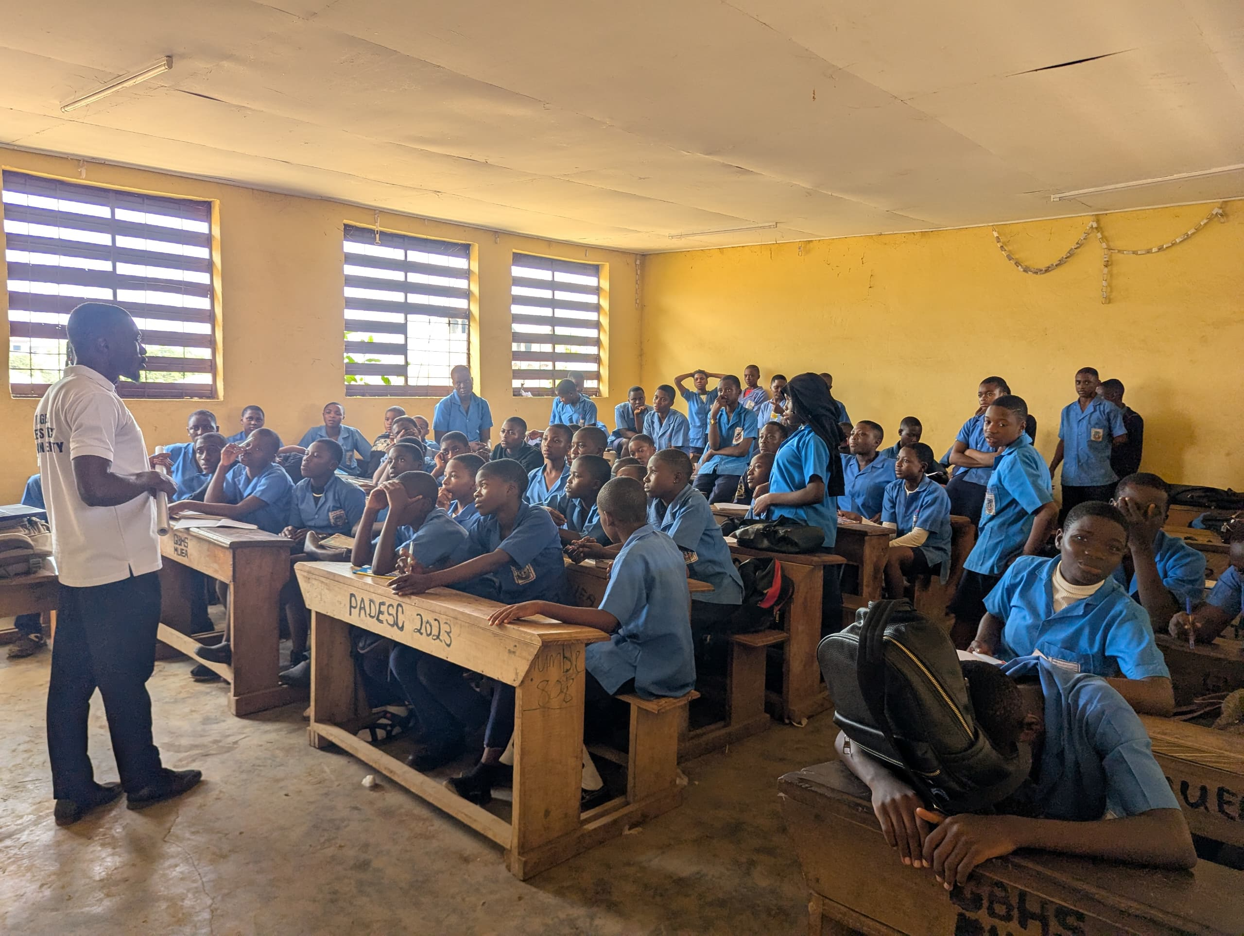
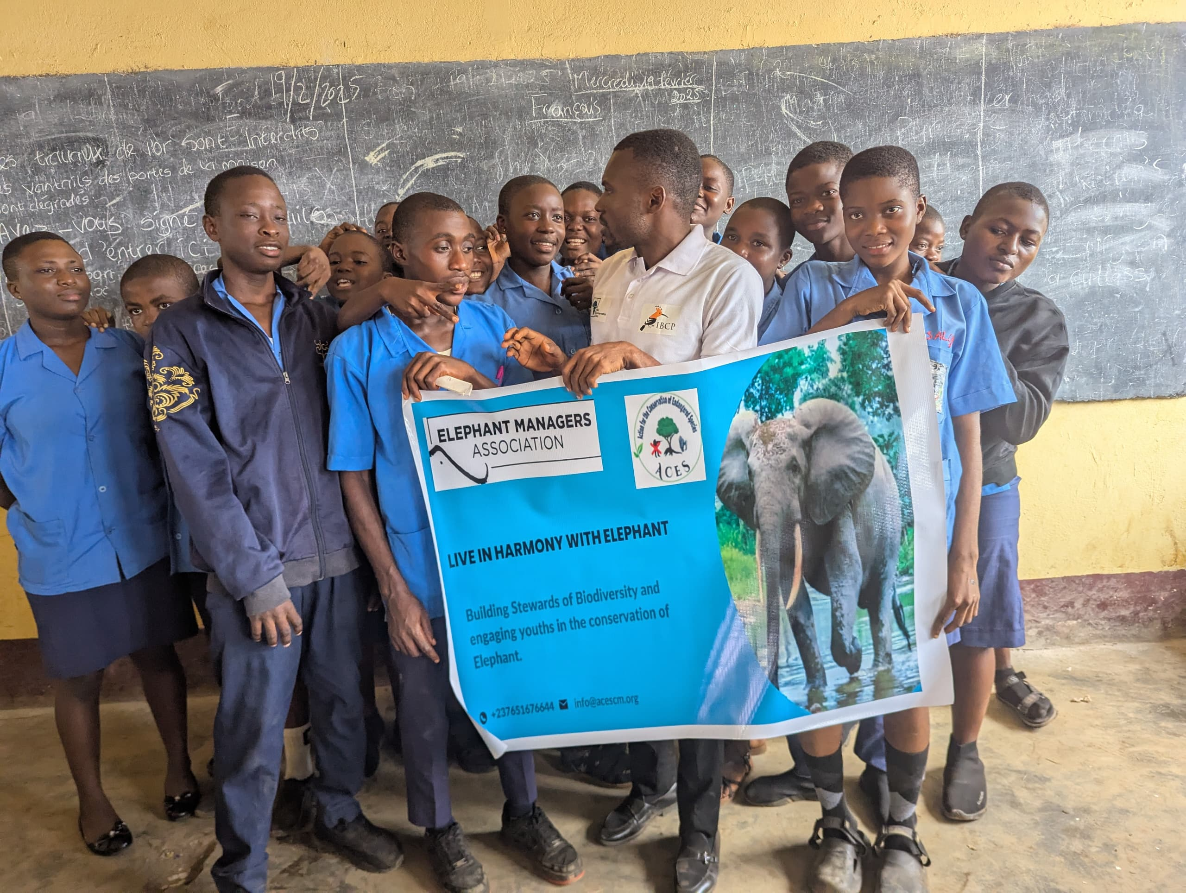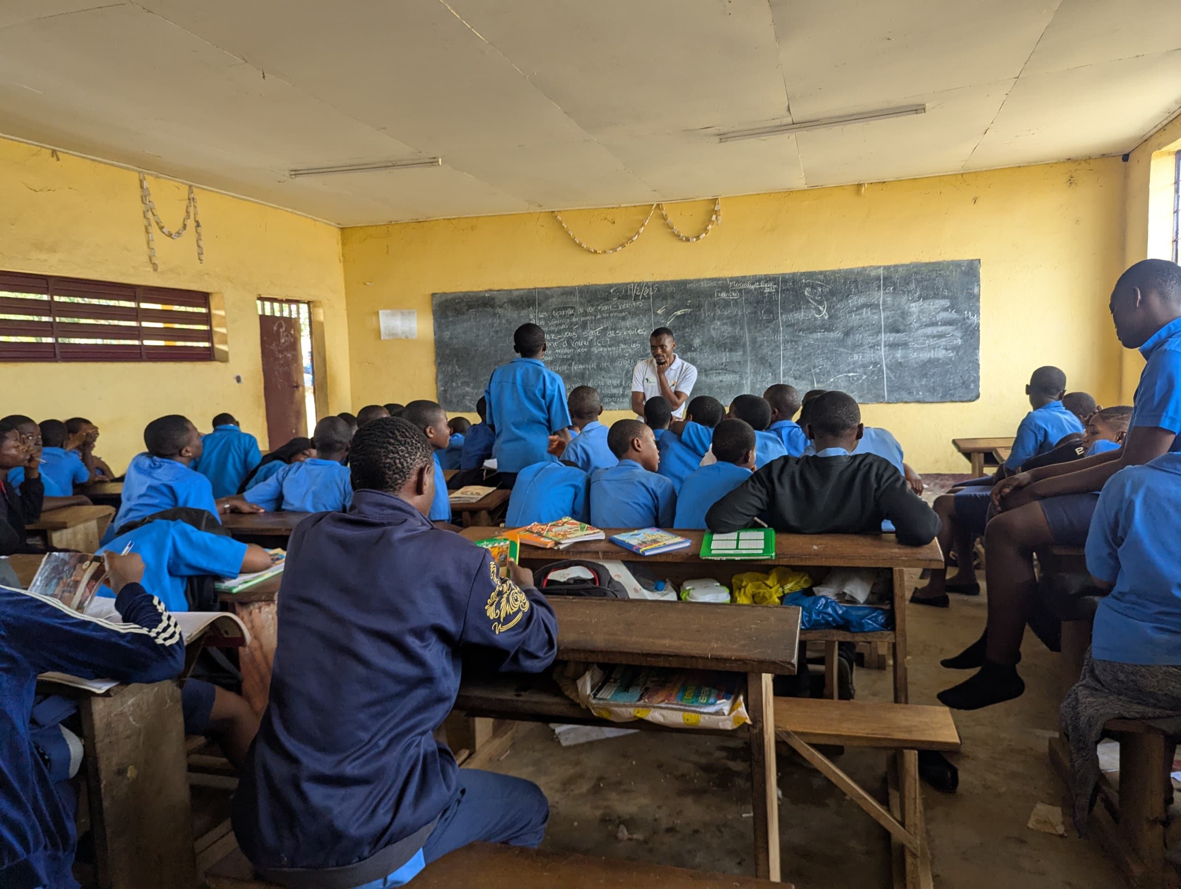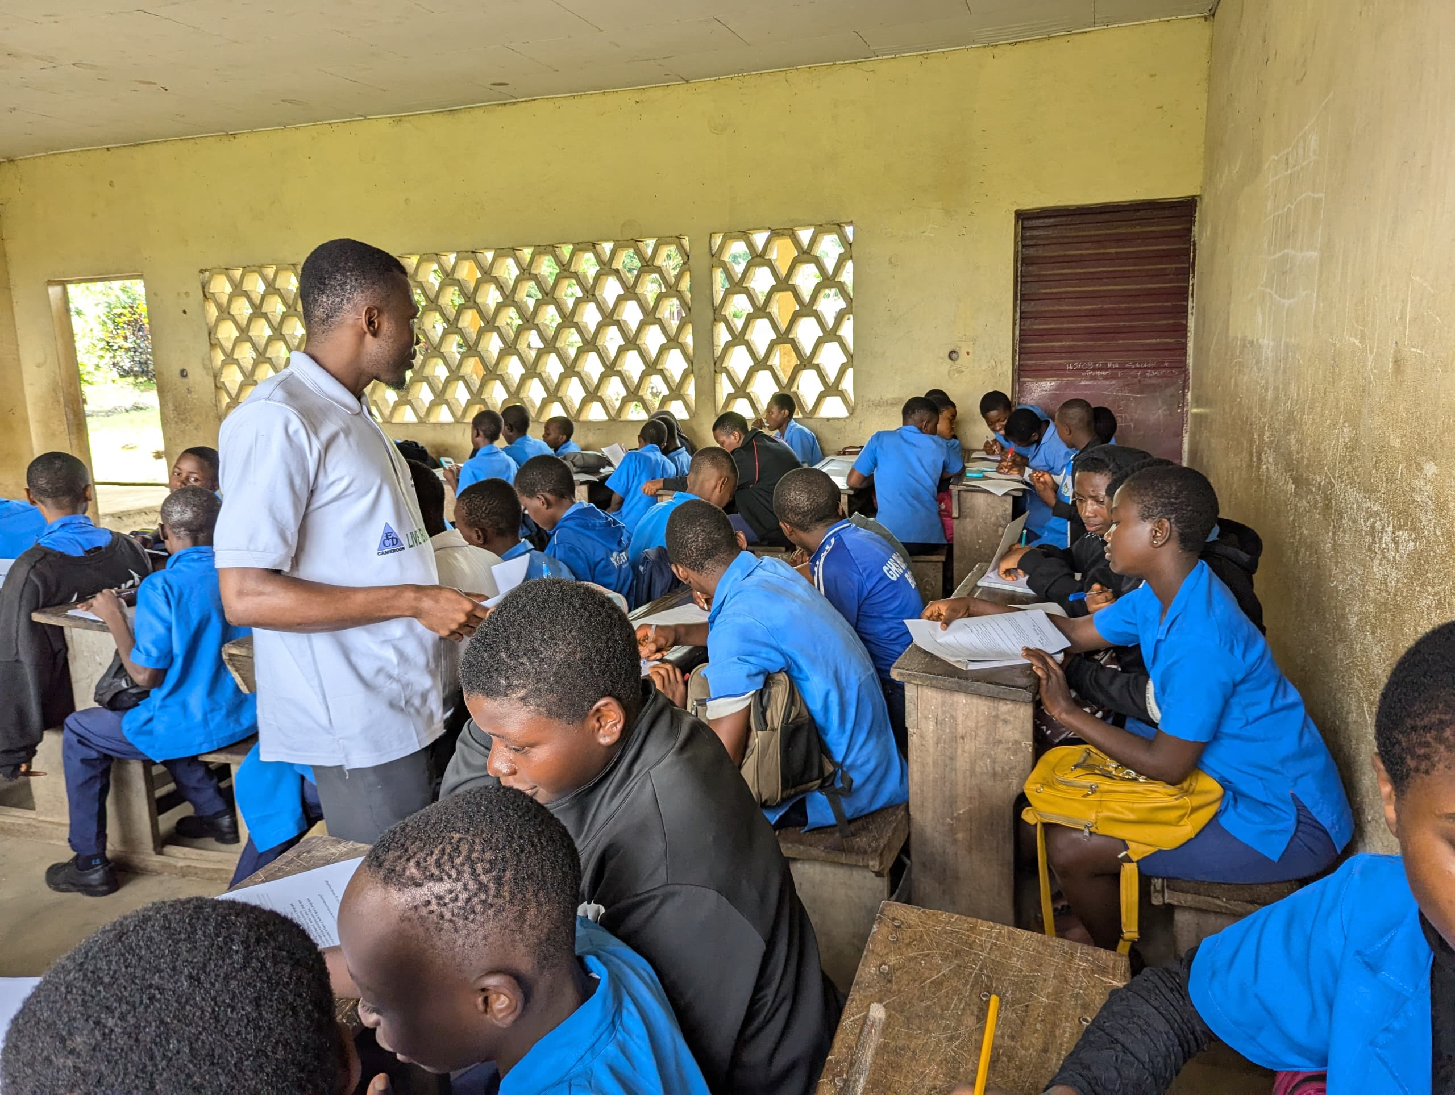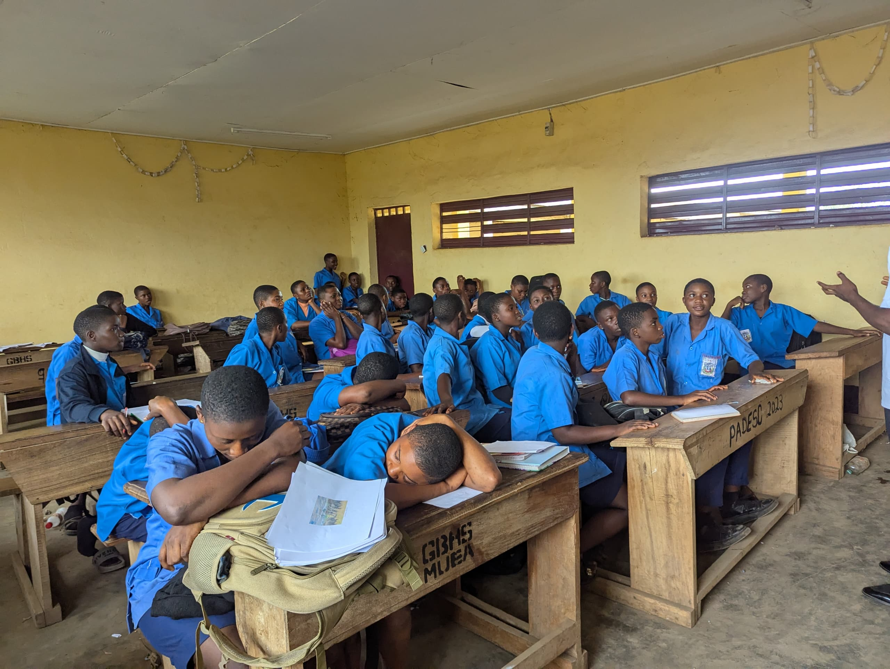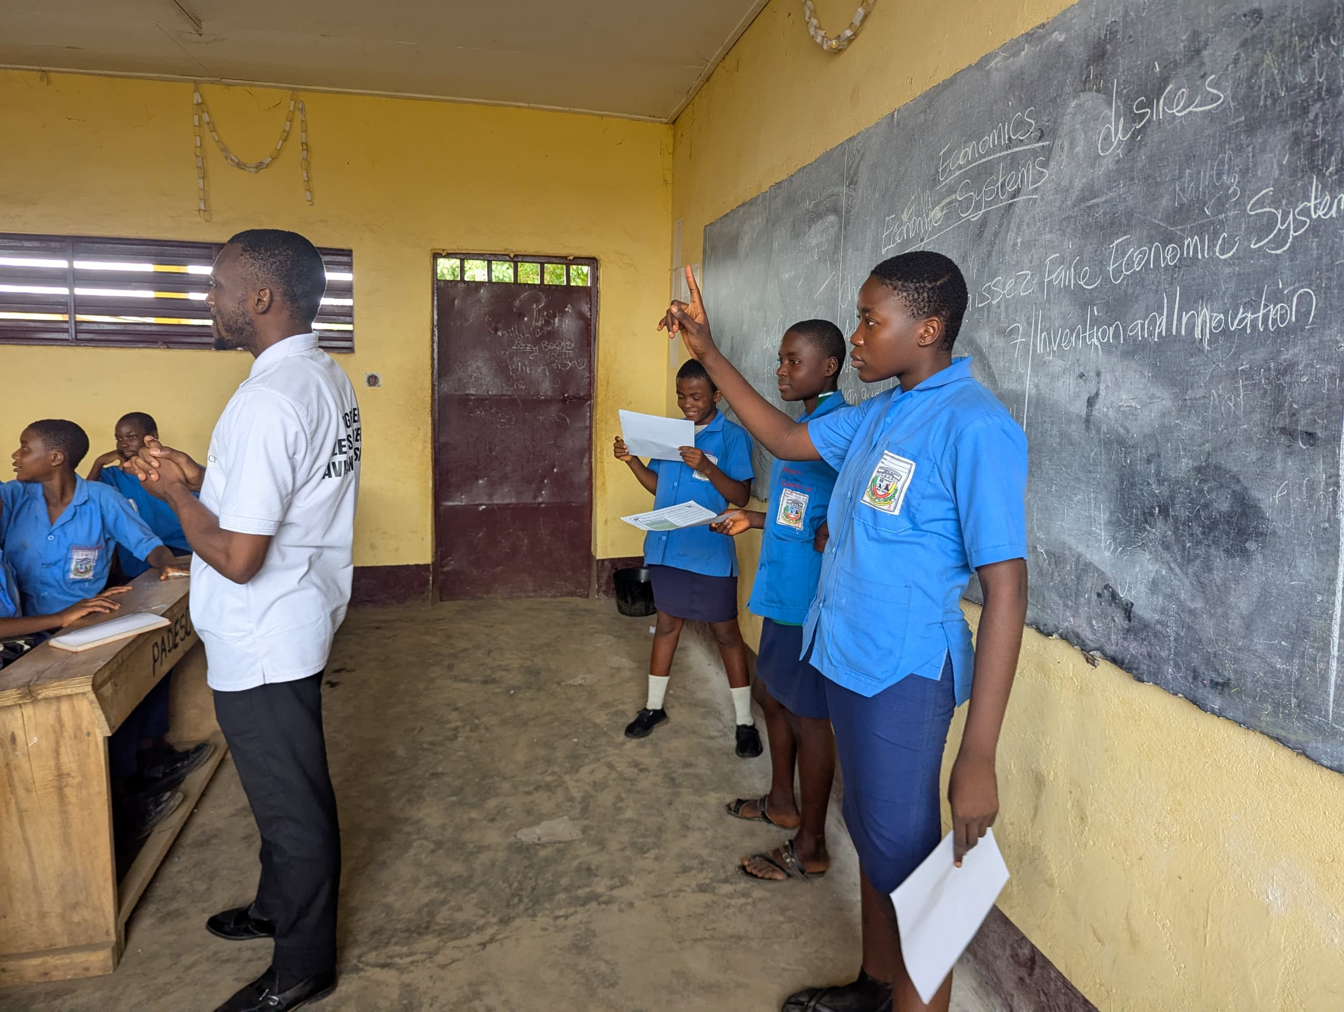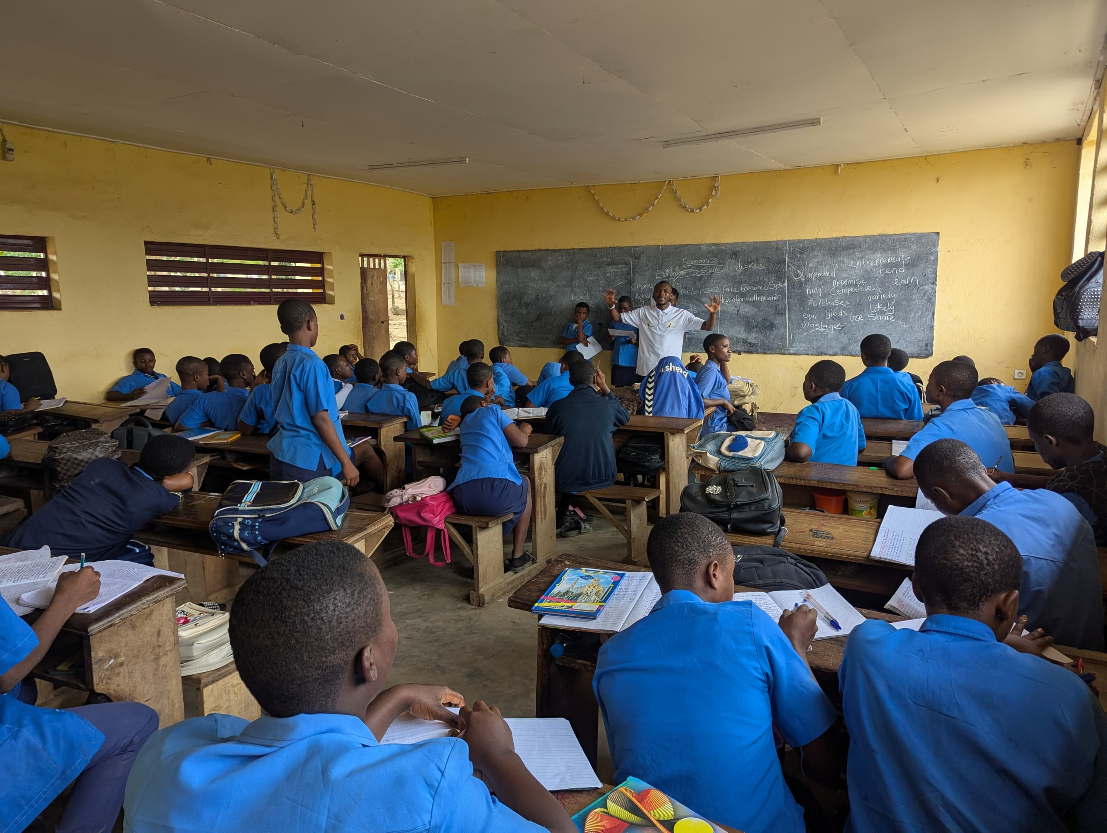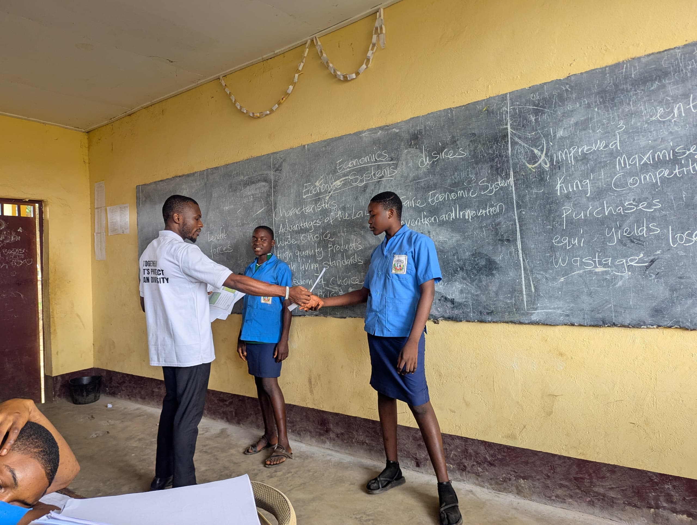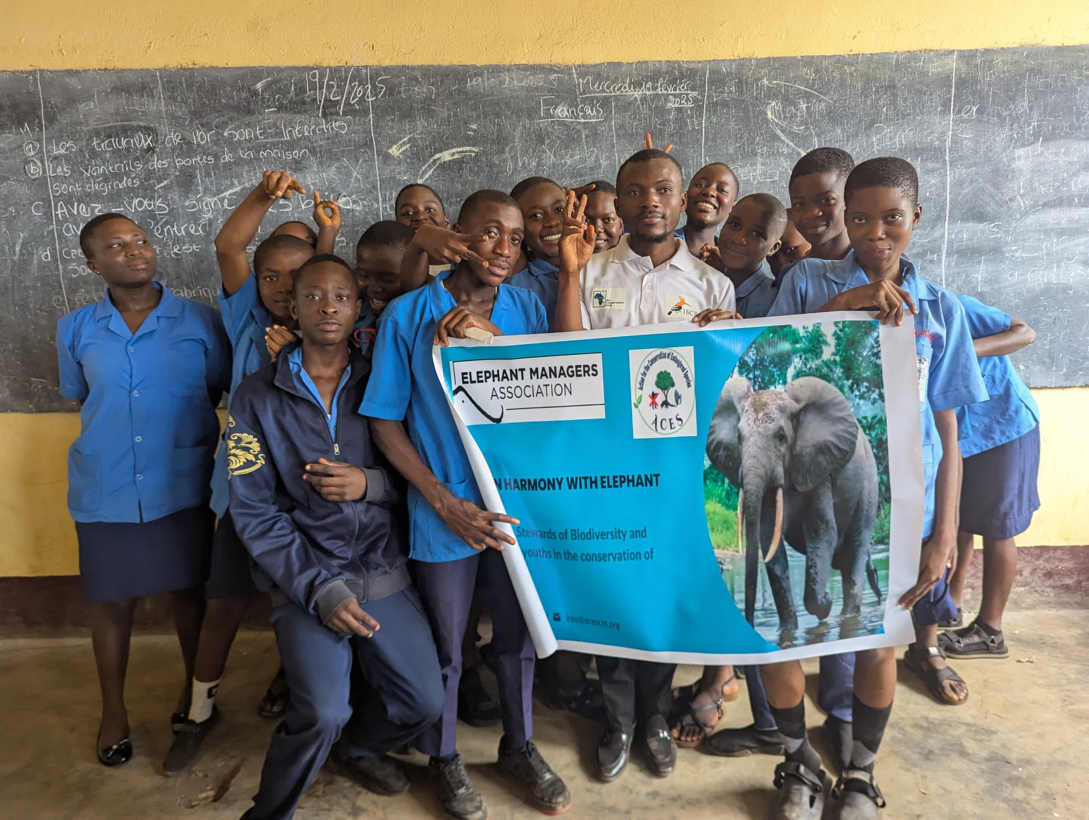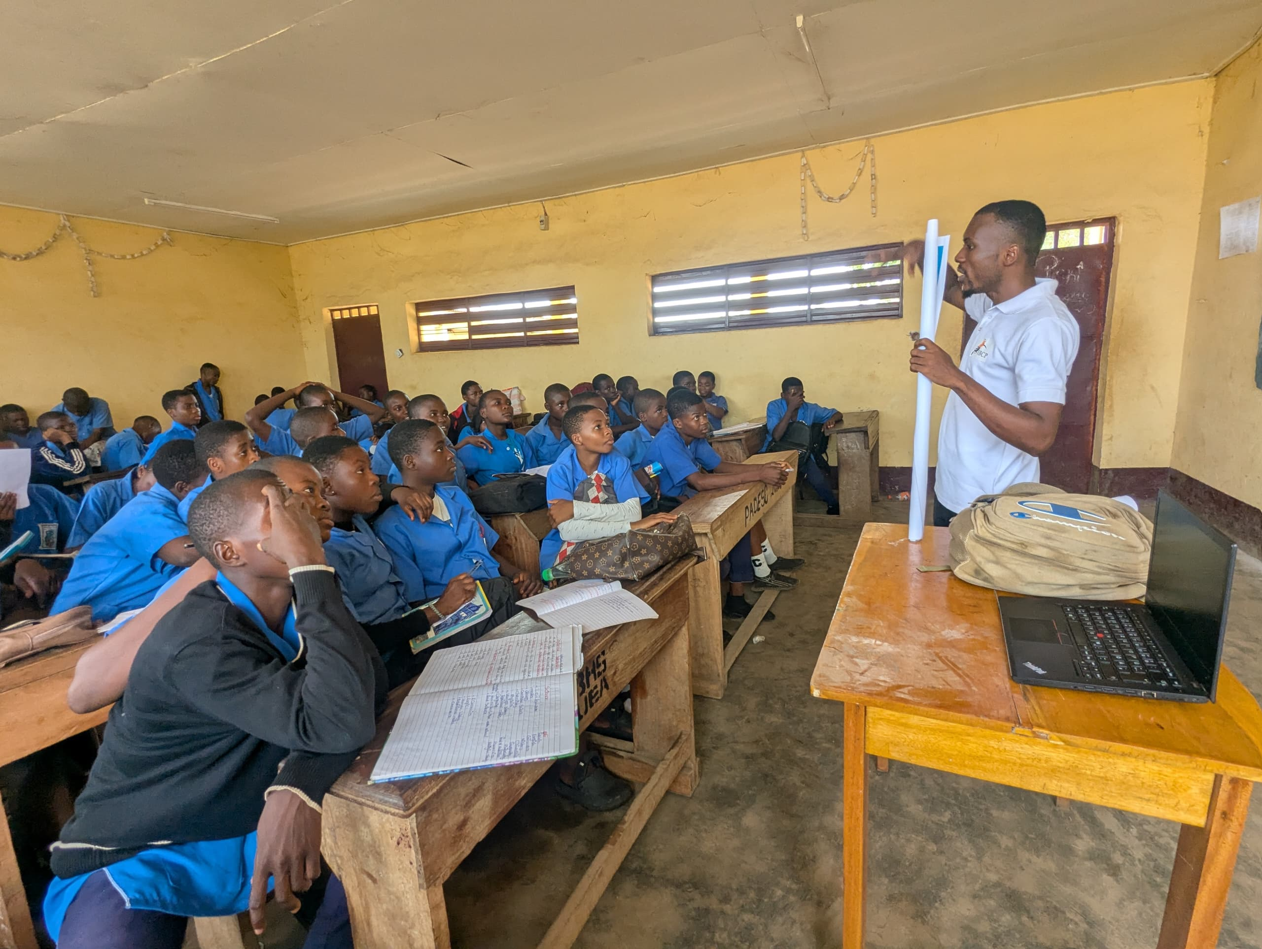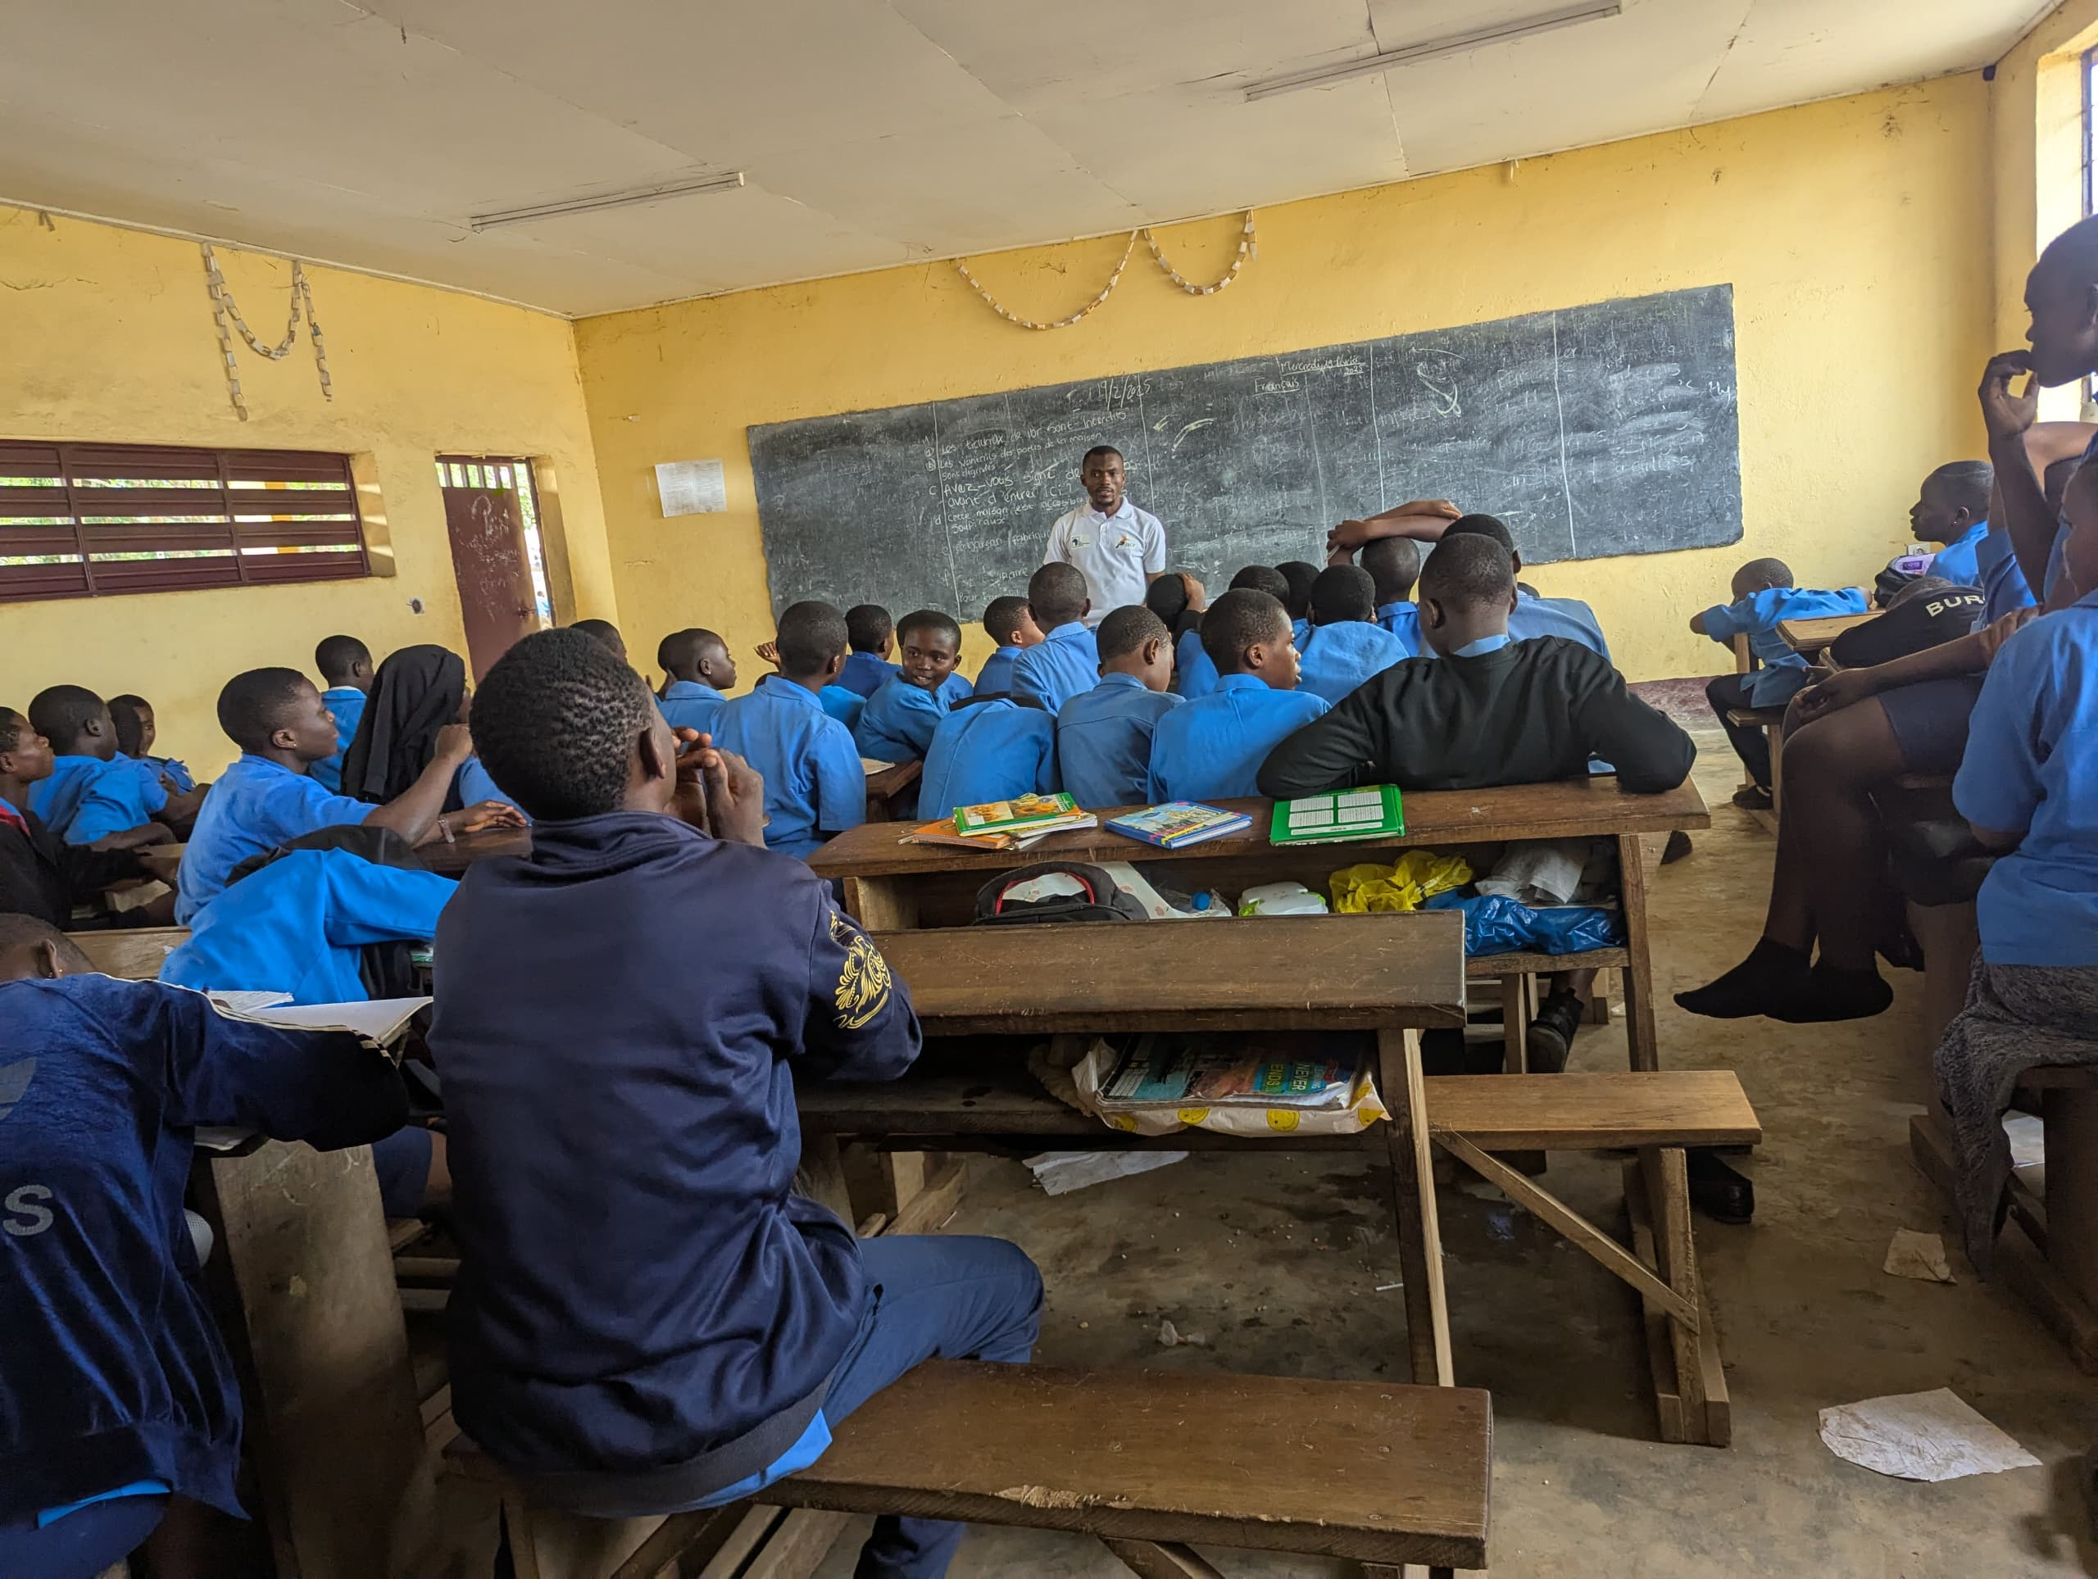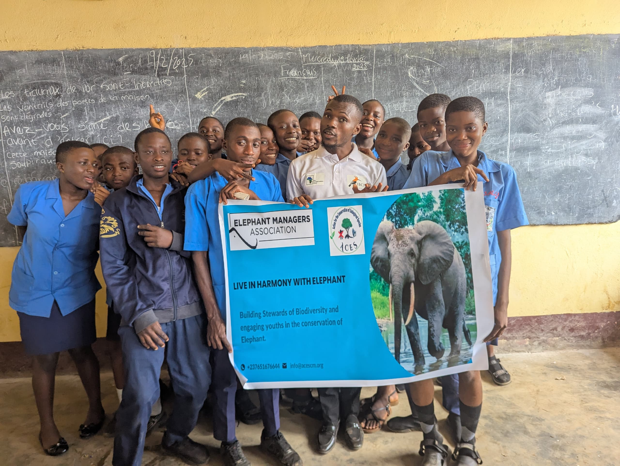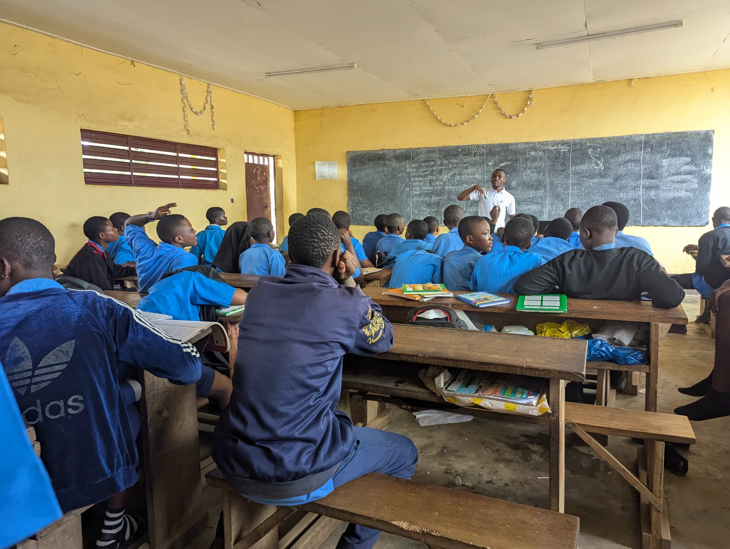

Appendix D. Outdoor games
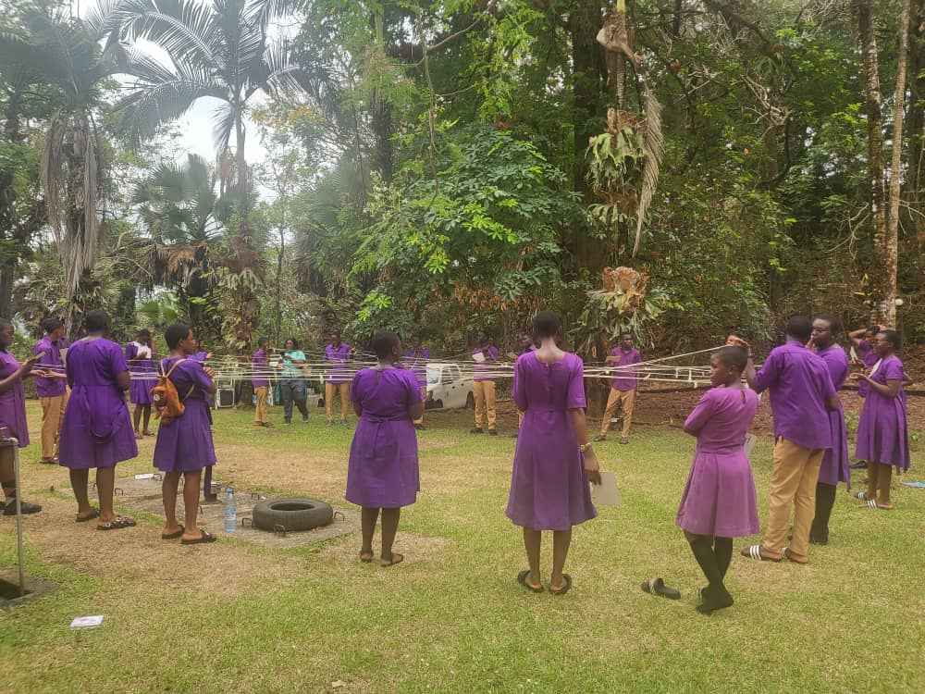
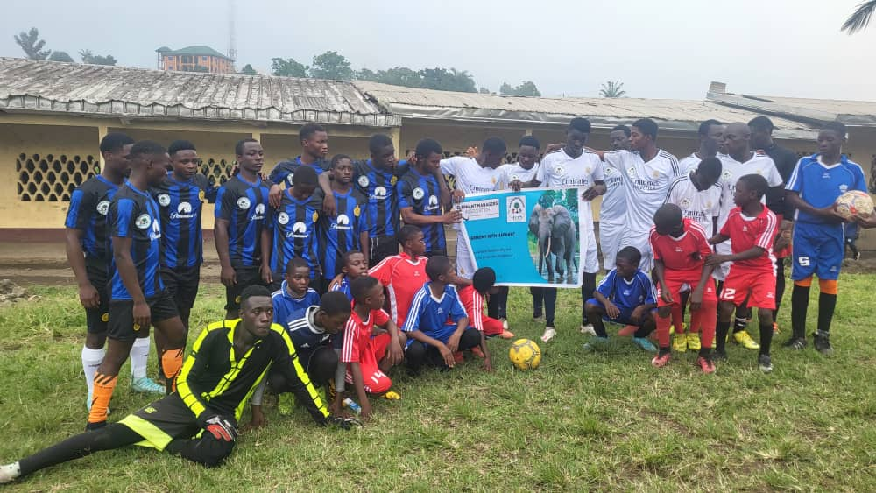

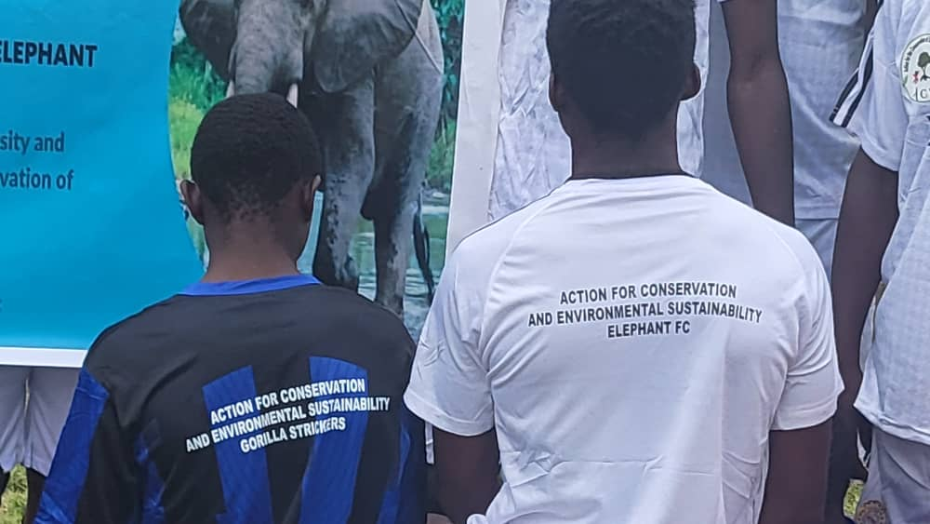

Appendix E. Brochure for students and banner
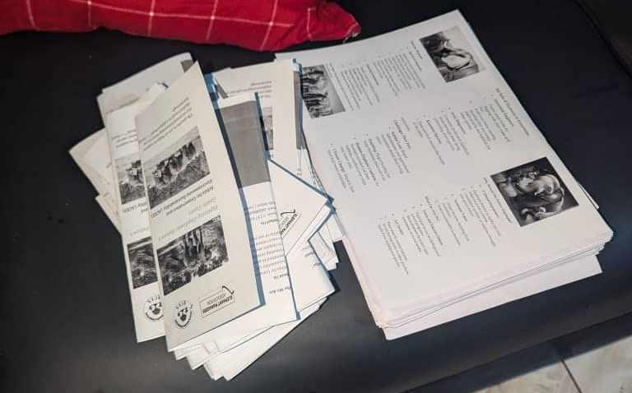


Appendix F. Testimonials
"Before this program, I saw elephants as just animals. Now I understand they’re ecosystem engineers without them, forests and biodiversity collapse. I’m committed to spreading awareness about their irreplaceable role". (Merriam)
"The program transformed how I view conservation. I’ve stopped buying ivory souvenirs and now encourage my family to support wildlife corridors. Elephants aren’t just symbols; they’re our responsibility" (James)
"Learning about human-elephant conflict solutions, like beehive fences, inspired me to organize a community workshop. This program showed me that local action can drive global change." (Lesley)

