**ACTION FOR THE CONSERVATION OF ENDANGERED SPECIES**

Final Project Report

**PROJECT TITLE**: Improving the Conservation of Elephants and other Wildlife Species in the Deng Deng National Park through Research, Education and Community Outreach

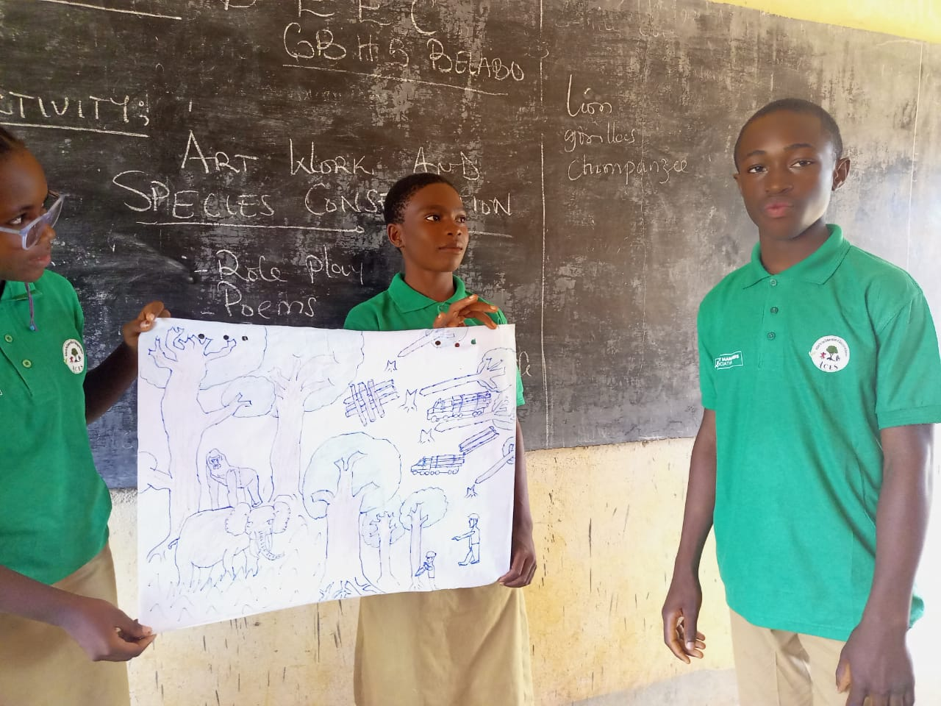

Prepared by

**ANGWA GWENDOLINE**

Project Coordinator ACES

Funded By**: Elephant Managers’ Association**.

ACKNOWLEDGEMENT

We acknowledge the ELEPHANT MANAGERS ASSOCIATION for their financial support to this project. We also thank the park management service and the conservator of the Deng Deng National Park for their collaboration in the successful implementation of this project. The school delegate for their cooperation without leaving out the traditional rulers and communities for their warm reception and collaboration in the project. To all ACES Staffs, volunteers and well-wishers we say thank you for your support.

Table of Contents

1 INTRODUCTION 3

1.1 OBJECTIVES 4

2 METHODOLOGIES 4

3 RESULTS AND DISCUSIONS 5

3.1 Sensitization campaign and establishment of environmental clubs. 5

3.2 Respondent’s Demographic and socioeconomic variables 7

3.3 The extend of human wildlife conflict 8

3.4. Traditional knowledge of human wildlife conflict management. 9

3.5. Community perception toward conservation 9

4 SUCCESSES, SHORTCOMINGS AND CONCLUSION 11

4.1. SUCCESSES 11

4.2 PROJECT SHORTCOMINGS 11

4.3 CONCLUSION 12

**SUMMARY**

This project was carried out in the Deng Deng National Park which is located in the East Region of Cameroon, precisely in the Lom & Djerem Division and covers an area of about 523 km2. It lies between latitude 13**°** 23 to 13**°** 34 East and longitude 05**°** 5 to 05**°** 25 North, in the North-Eastern part of the lower Guinean forest. The project was aim to improve on the conservation of the critically endangered African forest elephant and the western lowland gorillas by, evaluating the perception and effectiveness of indigenous knowledge in managing human elephant conflict, engaged 250 youths and student in 5 schools around the Deng Deng National park on the conservation of wildlife through the establishment of environmental clubs and lastly to sensitized 500 people in 10 communities on the importance of conservation through the printing and distribution of brochures.

The project was implemented between September 2022 and April 2023 and the following results were achieved; five environmental clubs established with a total of 390 students involve in the education program. Approximately 1000 people were sensitized through environmental club activity and distribution of brochures, 750 brochures were distributed in 6 communities. 100 questionnaires administered in five communities and results shows that, the existing human wildlife conflict has drastically increased over the past two years. 100% of the participant attest to have experience crop raiding either by elephants, Gorillas and or Chimpanzees. Only 22% of the participant attest to using local methods in managing wildlife conflict such as scarecrow which is not effective for Elephant and Apes which are the main concern. They also attest to other effective method such as bee hive fencing, and Chili pepper but cannot apply these methods since they have little or no experience and skills in their implementation. There has been very limited intervention from the park service with no compensation of damages. The conflict has caused a 40% reduction in food crop production and force many youths into hunting. The proximity of the park to the communities (500 meters to two kilometer) is too small hence very little land is available for agriculture. 80% of the farmer cultivate plantains around the park periphery and plantain happened to be a very important food sources for apes thereby increasing the rate of crop raiding. The project has help us to defined new livelihood projects and we have secure funds from the Rufford foundation to support bee hive fencing which was propose as an effective method of conflict control while increasing household income.

# **1 INTRODUCTION**

Buffer zones around parks/reserves are designed to maintain ecological integrity and to ensure community participation in biodiversity conservation (Lamichhane et al., 2019). Rapid economic and population growth has caused a huge demand and pressure on wildlife resources and their living environment therefore, Human–wildlife conflict is definitely inevitable when the area for human Settlement overlaps with wildlife habitat (Samojlik, 2018). There is a declining population of Elephant and Gorillas in the Deng Deng National Park as a result of overlapping human wildlife habitat especially in the northern part of the park where the elephant population is dominant. These species (African Forest Elephant and Western Lowland Gorillas) are listed as critically endangered according to the IUCN red list of classification. (IUCN, 2021). According recent park reports, there has been several cases of crop raiding by gorillas in the southern part of the park and Elephant conflict with human in the northern part of the park due to their close proximity to the forest. In retaliation, these species are killed causing serious threat to their already declining populations. To address this, we need to understand the perception and knowledge of local communities in handling Human Wildlife Conflict. More so, since youth between the ages of 19 to 30 gain a large portion of their livelihood from the forest, they tend to engage in group hunting and in the dry season when the catch is low, they result to a more easy and flexible tactics of bushfires which destroy the habitat and kill a host of species. Most of the youth who carry out this practice are not aware of the damage their actions pose to the environment and wildlife.

## **OBJECTIVES**

* To established 5 environmental clubs in 5 schools and conduct sensitization campaigns that will engage 250 youths and student in 5 schools and 500 people in 5 communities on the conservation of wildlife through outreach and youth engagement
* Understand the perception of local communities and effectiveness of indigenous knowledge in managing human wildlife conflict so as to suggest suitable mitigation measures to reduce and prevent Human Wildlife Conflict within the area

# **2 METHODOLOGIES**

This project was carried out in theDeng Deng National Park. The park is located in the East Region of Cameroon precisely in the Lom & Djerem division between latitude 5°-5° 25’ N and longitude 13°- 23° 34’ E in the North-Eastern part of the lower Guinean forest. The Park is characterized by an equatorial and humid climate with annual rainfall ranged from 1500-1600 mm3 per year. Seasonal pattern in the park area is characterized by dry and wet season of unequal periods with a mean annual temperature of 23°C.

This project took place in 5 communities (Tete d’elephant, Ligiem, Lom, Mbaki village, and Deng Deng) around the park. the villages were selected based on the recent park report on villages mostly affected with human wildlife Conflict. We organized a project planning workshop with the park management team to evaluate past project reports, select targeted communities and schools and discuss on the successful implementation of the project. Field work runs from September 2022 to February 2023. The schools were mobilized and environmental clubs established with support from the school administration. Each school appointed a Club coordinator to manage the affaires of the club and to educate clubs members on different conservation topics. The student participated in storytelling, art work and outdoor environmental activities. The second objectives were achieved through questionnaire administration, using one on one interview and focus group discussion in 5 villages around the Deng Deng National Park. A total of 100 questionnaires were administered in five villages that is 20 questionnaire per village. The data collected during the socioeconomic survey was analyze using excel.

# **3 RESULTS AND DISCUSIONS**

# **3.1 Sensitization campaign and establishment of environmental clubs.**

The project successfully established 5 environmental clubs in five schools around the DDNP. The five schools selected were: Government Bilingual High School Belabo (GBHS), Lycée Classique de Belabo (GHS), Centre of Excellence Bilingual College (CEBICOL), Government technical College Deng Deng (CETIC) and Government Secondary School Deng Deng (GSS). Student of the above mention schools were mobilized and the club establish. more than 70% of the population of each school was interested in becoming members of the club and everyone was allowed to participate in the program. The clubs had a total of 390 students distributed as follows. GBHS Belabo (175), Lycée Classique Belabo (115), Centre of Excellence (35) CETIC (25) and GSS (40). Club activities were set for Wednesdays and Fridays. 150 t-shirts were printed 20 was set aside for the park service, ACES team and school coordinators and 130 distributed to the five schools according to their engagement in the program. Conservation education took place once every week in all the school from October 2022 to February 2023 except for schools in Deng Deng where we could only reach out once a month due to the distance.

Wildlife arts were produced by students and this was use during sensitization and on the 11th of February celebration student were given the opportunity to explain their art to understand the story behind their drawings. A medicinal garden was also established in one of the schools. The garden made use of organic manure produce by students of the club. The manure was made from grasses cleared within the school. Instead of burning the grass which destroy the soil and reduce soil fertility, we thought the children an easy way to transform waste into manure as a way to fight bush fire. 30 economic trees were also planted in school to provide shelter in the long-term.

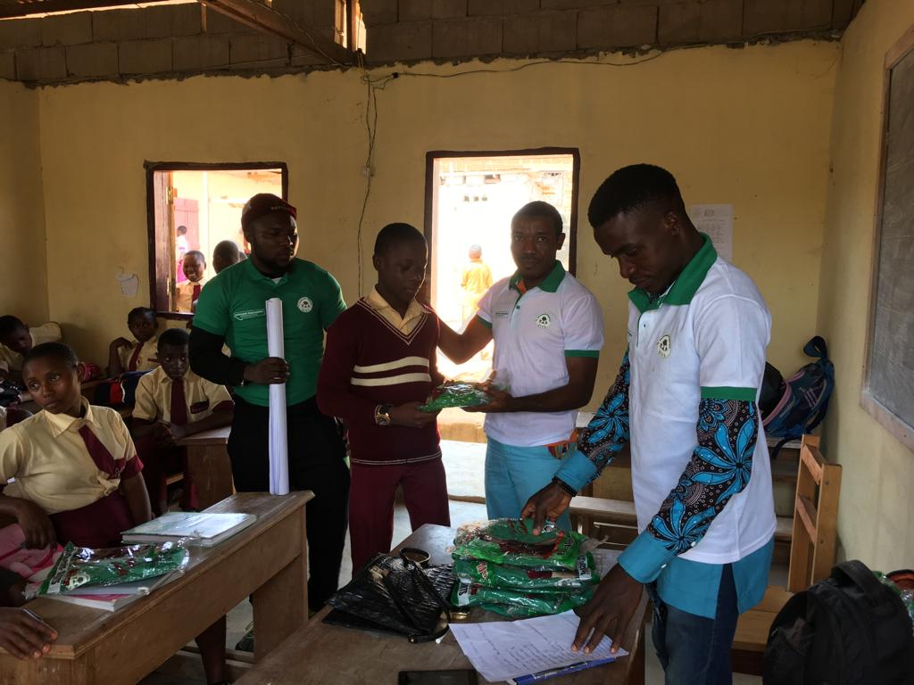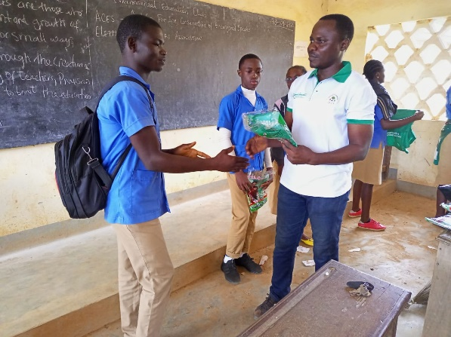

Figure T-Shirt distribution in CEBICOL

Figure T-Shirt distribution in GBHS Belabo

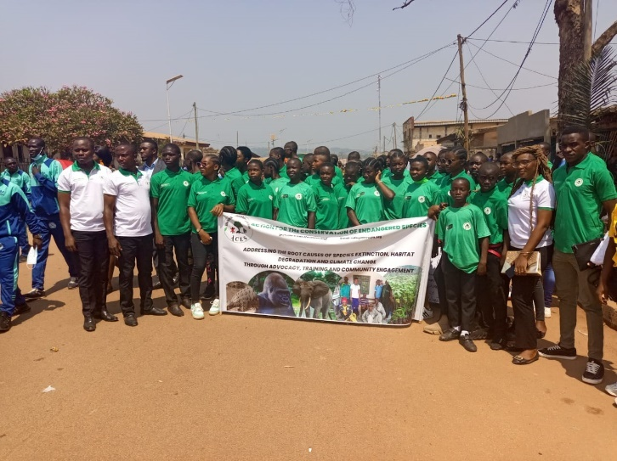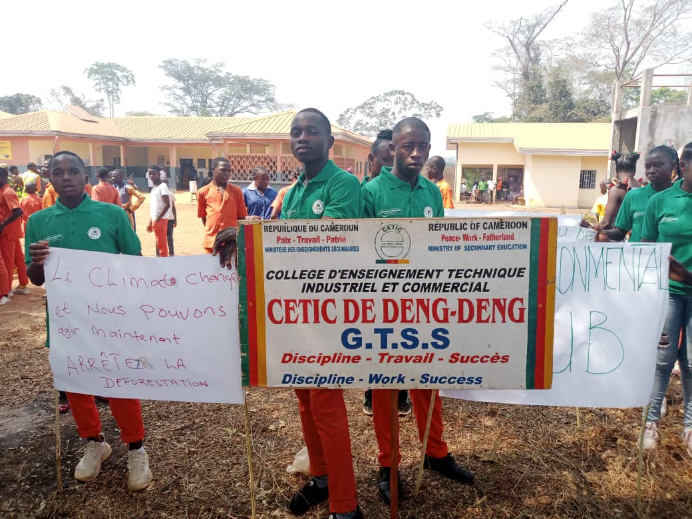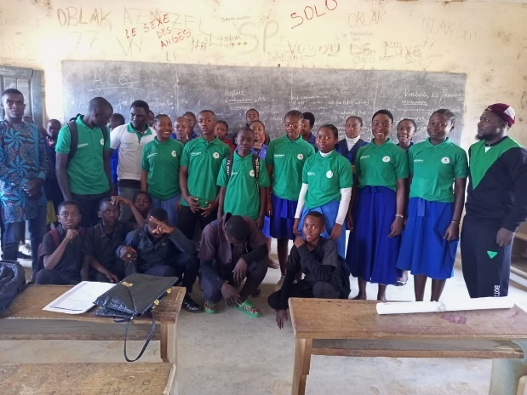

Figure : EE CLUB Lycee Classique Belabo

Figure : Youth Day celebration in Deng Deng

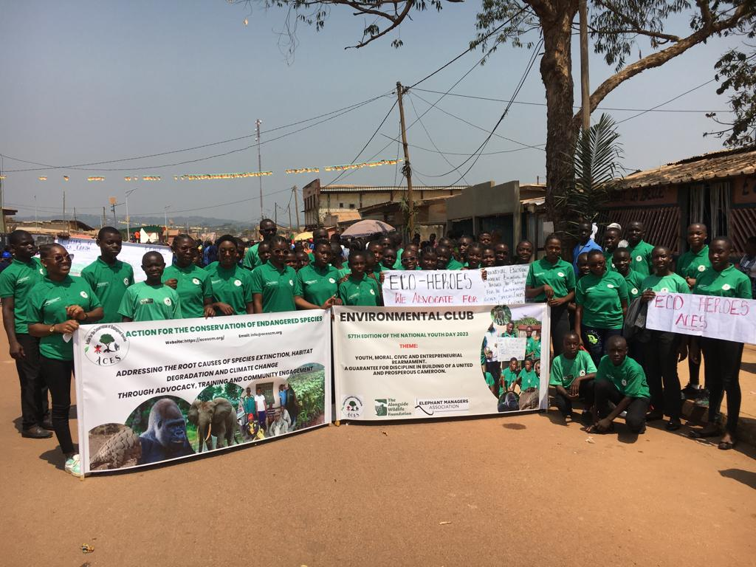

Figure : youth day celebration

Figure : Youth Day celebration in Belabo

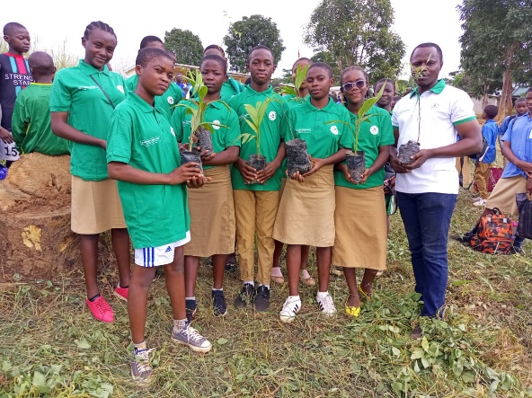

Figure : Tree planting

# **3.2 Respondent’s Demographic and socioeconomic variables**

The study was aim at understanding the perception of local communities and effectiveness of indigenous knowledge in managing Human Wildlife conflict. A total of 100 respondent in five villages were interviewed. we had 73 men and 27 women. the number of women were lesser than those of men because women are not that engaged in village affairs hence some shy away to respond and some are of the Muslim background who to them is against their tradition and belief. A greater number of the respondent were predominantly farmers (82% n = 100), 7% Hunters, 6% bushmeat venders and 5% other profession (teachers, petty traders). All participant accepted that they own a farm within the communities. This shows that the area is dominated by farmers and almost all the farmers admitted to be engaged in poaching at a minimal level. The fact that the majority of respondents (82%) are small to medium scale farmers who reported farming as their sole occupation may have implications on conservation in the sense that it increases the likelihood of human wildlife conflicts (HWC), particularly due to crop raiding. Incidences of HWC are likely to increase if land clearing for agriculture and settlements remains unchecked as eco-guards do not yet have the means necessary to scare and repel animals from farmlands. The area is dominated by Christians 65% (n = 100), Muslims 26% (n = 100), traditional believers 5% and 4% being free thinkers. 60% (n = 100), of the participants are indigens of the areas who have lived in the communities all their life’s and 40% have been in the village between 5 and 10 years. The birth rate in these villages is high with 79% of participants having 5-10 children and 21% having more than 11 to 15 children. Unfortunately, the educational background of the community is low with 3% completing higher high school, 17% dropping out of secondary school, 55% completed primary school and 25% with no education.

# **3.3 The extend of human wildlife conflict**

From the study, we were made to understand that there exist human wildlife conflict and it is increasing as years are passing by, with 44% of participants attesting that their plantain farms are destroyed, 33% attesting that their maize farms are destroyed, 14% attesting that their cocoa farms are destroyed and 9 % attesting that other crops are destroyed mainly by elephants, hippopotamus (Tete d'elephant and Ligiem village) gorillas and chimps (Lom, Mbanki and Deng-Deng village). According to the participants, 15% affirmed that they have experience physical confrontation or attached from wildlife either on their way to the farm or in the forest. No one has been reported dead as a result of conflict in the last five years. the distance from the park boundary to the village is less than 3 kilometer as 41% of the participant attest that their farms are found less than 1kilometer from the park boundaries, 29% less than 2kilometers, 30% less than 3 kilometers. The increase conflict in the area is as a result of several reasons. Firstly, the proximity of the communities to the park boundaries and the absence of a buffer zone for effective management of the park. Since the national park does not have a buffer zone, it exposed food crops to more danger as wildlife species leave the park directly to farms in search of food.

Secondly the types of food crops cultivated around the park periphery is also very important. Most farmers cultivate plantain, maize, cassava and cocoyam’s. Gorillas are plantain stalk lovers and will definitely come for food in farmlands especially during the dry season when the forest is dry. The third and last reason is the destruction of wildlife corridors through deforestation by timber extracting companies. In the northern part of the park as the case of Tete d’elephant and Ligiem. Two new forest management unit set aside for exploitation of timber has distorted the elephant corridor in the northern part of the park. This distortion has increase conflict in the area. The elephant now moves into the villages causing chaos and destruction as they struggle to find their way back into the forest and or moves to the neighboring National Park. The community members also explained that the only land left for them to farm has an oil pipe line passing around and sometimes they experience oil spillage which causes the soil to be infertile and finally the Lom Panga dam which is few kilometers from the villages also causes the distruction of food crop such as Cassava due to constant flood in the dam especially during the rainy seasons. The frustration from all the surrounding happenings force communities to retaliate by engaging in other illegal activities as a means of livelihood. This has led to the imprisonment of many youths within the locality.

Considering that most of the respondents are involved in agricultural activities, their biggest complaint was that they were restricted from replacing large patch of primary forests with small-scale agriculture, which hindered their work and livelihood. This feeling was reflected in negative attitudes toward the park and forest conservation. Moreover, according to PA managers, illegal deforestation has been registered during law enforcement events recently conducted in the park.

# **3.4. Traditional knowledge of human wildlife conflict management.**

According to the responses of 100 participants within the five communities, 22% attested that they use local techniques to reduce crop destructions by animals. They use methods such as scarecrow, cassette tape vibration and animal fences. Dough the participants confess that these methods were not effective for large animals such as Elephant and Gorillas but it helps prevent small mammal and monkeys from crop destruction especially in their maize and cocoa farms. The participants also attested that they are aware of some effective local techniques such as bee hive and chili pepper fencing but do not have the skills to apply this method to reduce conflict in the area. The bee hive and chili pepper fencing has been proven effective in mitigating elephant conflict in the mount Cameroon National Park. These methods will be explored in the Deng Deng National Park to mitigate the effect of Human Wildlife Conflict.

* 1. **Community perception toward conservation**

The perception of local communities was analyzed on two areas that is the suitability of conservation management, use of wildlife product and knowledge of wildlife laws. The altitude of the respondent toward the establishment of the National Park differs 63% (n = 100) of the respondent appreciate the Park establishment and are happy with the work of eco guards in the management of the park and the main reasons was to give their children the opportunity to see the different wildlife species in the area. Despite the overwhelming number happy with the park management, 37% thinks the park is a hindrance to community development and livelihood since they are prohibited from entering the park and those who violate the law are apprehended and detained. The communities do not have any contribution to the day-to-day management of the park and hence they feel their livelihood is susceptible. All 100% responded recognizes the park boundaries and understand that it is strictly out of bands. They are more aware of illegal activities conducted in the park as opposed to the legal activities. For instance, poaching and tree cutting were the most frequently cited illegal activities in the park. This is corroborated by the number of respondents that felt that the wildlife in the park was decreasing due to poaching (68%) and 32% felt that wildlife populations were increasing primarily due to protection from government Eco guards. for law enforcement, 45% of the respondent believed that law enforcement is active in their communities and the effort has increase over the last two years while 55% comment that law enforcement is nonexistent or have a very low frequency in their communities (this was so for Tete d’elephant and Ligiem).

Furthermore,the research found that 85% of the respondent shows a negative altitude towards restrictions on wildlife harvest (hunting) and this was directly related to their religion. The communities base on their believe as forest dwellers say the consumption of wildlife is inbuilt as the they claim bush meat taste better than any other community domesticated animal. To them hunting for consumption should be legal and restricted only for commercial purpose. The reasons associated to commercial hunting based on the respondent was a fast way to raise income for their day-to-day life. They believed the law could be more flexible and only trade-hunters should be punished by law. Another very peculiar reason for wildlife harvest was because communities feel all attention is place on wildlife protection with no livelihood support project to forest adjacent communities to increase income and reduce their dependency on forest resources. Our results suggested that most respondents have a strong desire to hunt for consumption. This is a big issue because it goes against the policies and the Cameroon wildlife law and represents a potential threat to wildlife conservation inside Deng Deng National Park. In addition, illegal hunting has been of great challenge in the project site (Diangha, 2015)

Our study suggests that to change behaviors of local communities toward different motivations for hunting and deforestation in and around the Deng Deng National Park, management actions should consider people ‘s attitudes and norms and the combination of background factors that influence these variables. Raising compliance with conservation policies in the park is challenging, particularly if we consider that managers have scarce human and financial resources (Castilho *et al*. 2018). It is therefore essential to engage local people to a greater extent, guaranteeing that communities and their concerns will be included in the implementation of current management plan and strategies.

# **4 SUCCESSES, SHORTCOMINGS AND CONCLUSION**

# **4.1. SUCCESSES**

* We have successfully established five environmental clubs
* We have engaged more than 500 students in conservation practices
* We have deepened our understanding of community perception and challenges face by forest adjacent communities
* We have designed a long-term program to mitigate human wildlife conflict and improve community engagement in conservation within the target areas
* We established a medicinal garden to teach students about gardening, waste recycling and sustainable environmental practices
* We planted 50 trees to create shades and beautify the school campus while improving carbon sequestration in the long term

# **4.2 PROJECT SHORTCOMINGS**

* We could not fix a time for training with the clubs as this program is yet to be involve in the school time table hence, we relied on teaching the students after classes and when we were call abruptly.
* The number of T shirt printed for the Environmental clubs were not enough for all the students of the clubs and those who didn’t have where not motivated to participate in the weekly program.
* We could not achieve the award to best environmental clubs’ students as the funds available for that was use to trained and motivate the different clubs’ coordinators.
* The project targeted 5 communities and hence the perception of the communities in this project does not reflect that of the entire park villages

# **4.3 CONCLUSION**

Despite the project shortcomings, it is the first attempt in the area to documents the factors leading to HWC and understanding community perception to the management of the park. Community perceptions played a very important role in their attitudes toward the management of the park. This suggest that recognizing, strengthening and incorporating community perception into strategies to improve collaboration of park staff and community. This together with more traditional approaches such as sustainable extraction and alternative livelihood strategies has been proven valuable in improving community perceptions and can also strengthened their support for conservation.

Conservation organization must begin to perceive local people as potential partners, not perpetual poachers. Also, communities must recognize eco guards as law implementers doing their jobs, and not simply as harassment staff. This will encourage the development of a new conservation model “**community-based conservation” (CBC**), emphasizing management of biodiversity by, for, and with local communities (Naughton-Treves, 1997).